**LAMBDATEST PLAYGROUND: BUG REPORT**

**Date: -04-10-2024**

**Name: -Sanket Sarode**

| **Platform** | **Browser** |
| --- | --- |
| **Windows 11** | Chrome |

| **Who Detected** | **How Detected** | **Status** |
| --- | --- | --- |
| **Sanket** | **Testing** | **Open** |

Bug_001

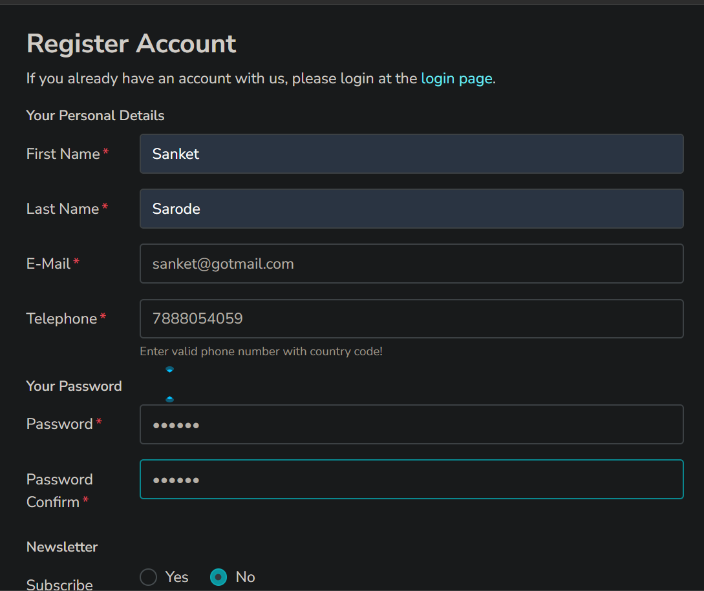

Bug_002

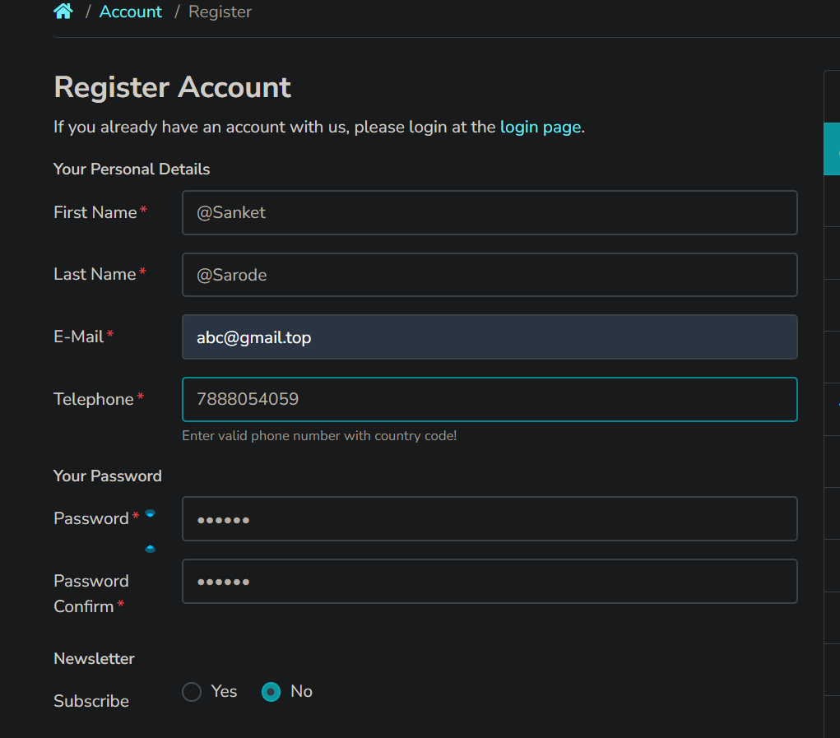

Bug_003

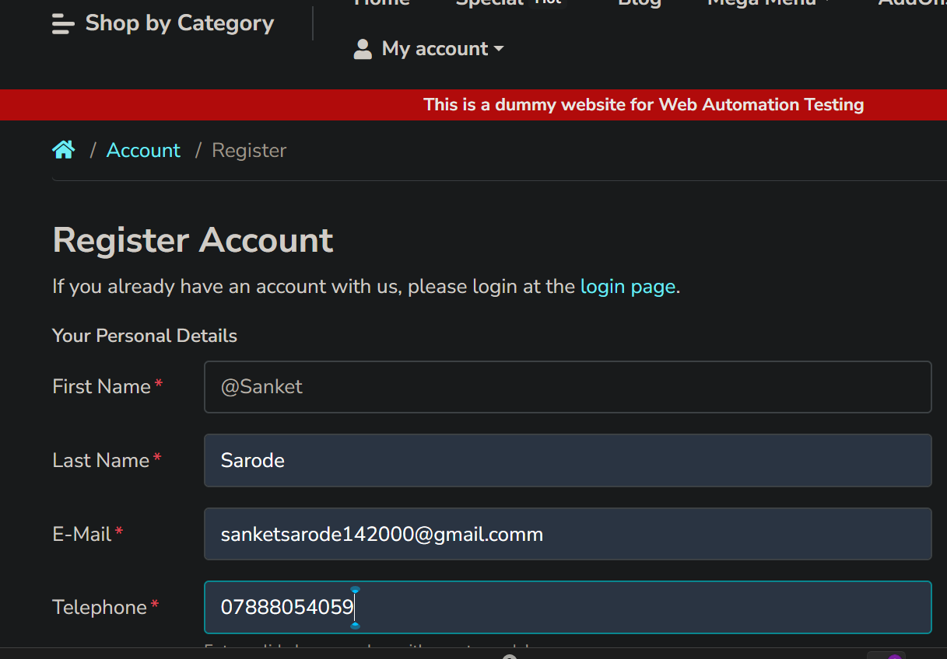

Bug_004

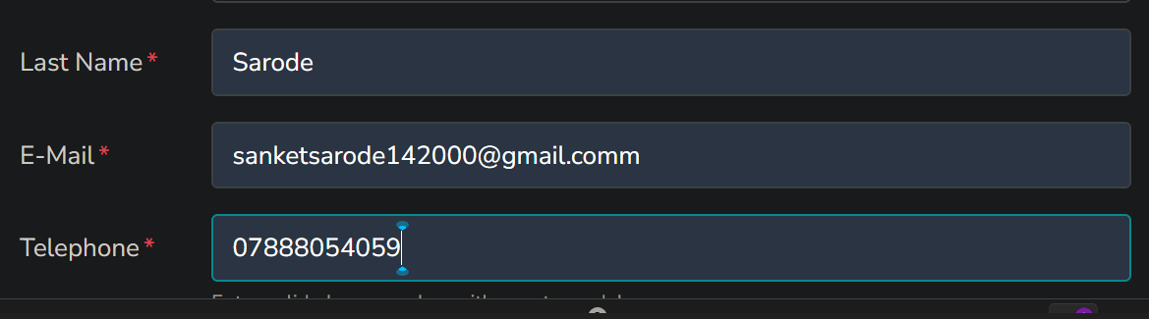

Bug_005

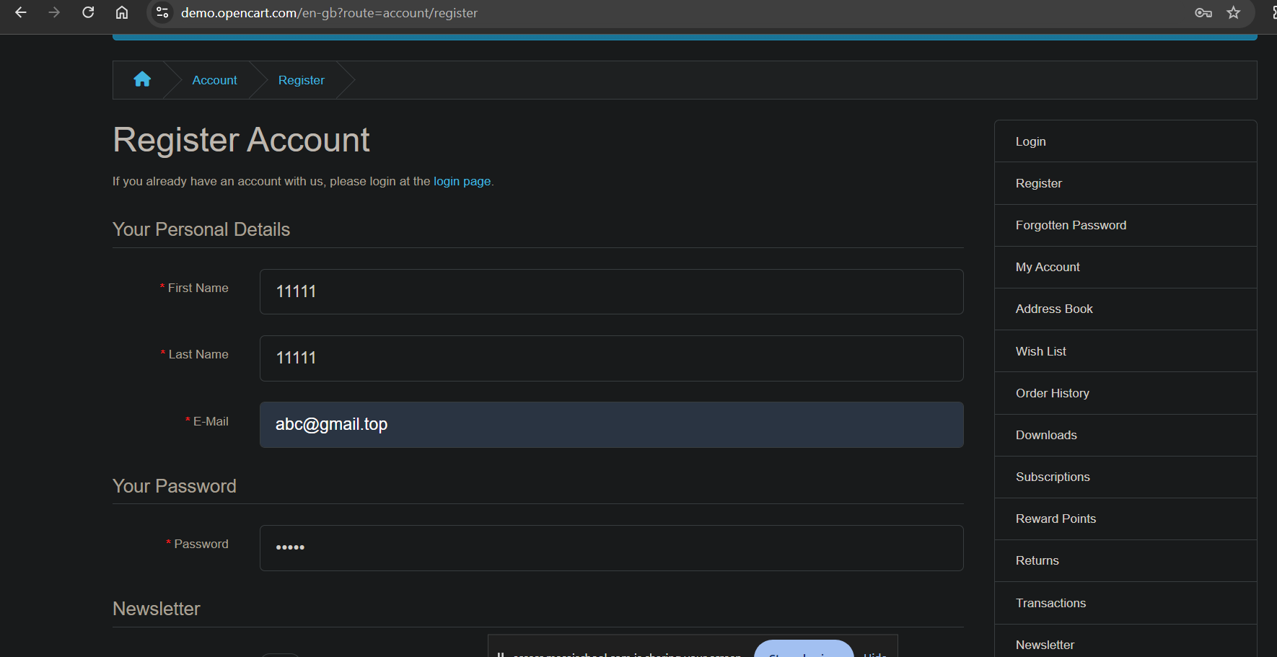

Bug_006



Bug_007

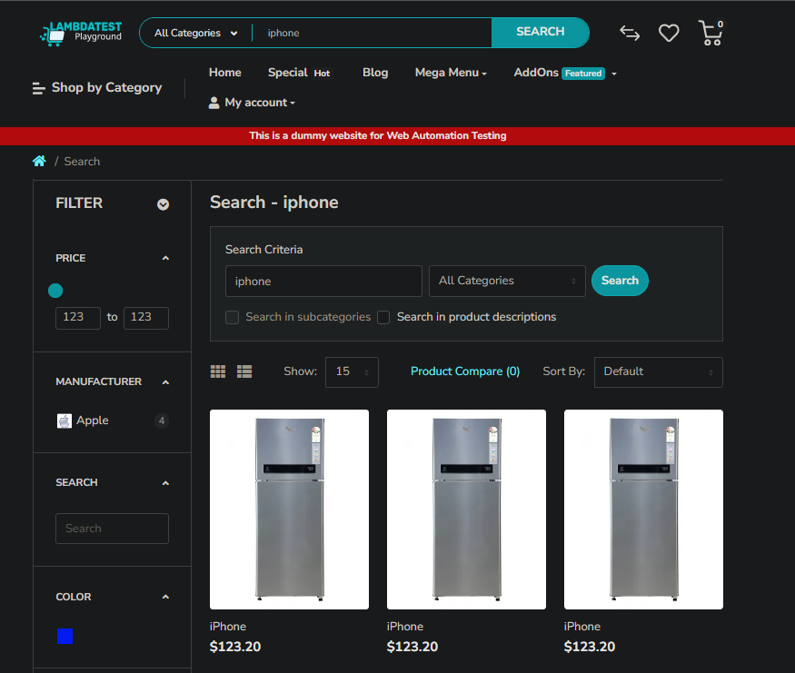Bug_008



Bug_009

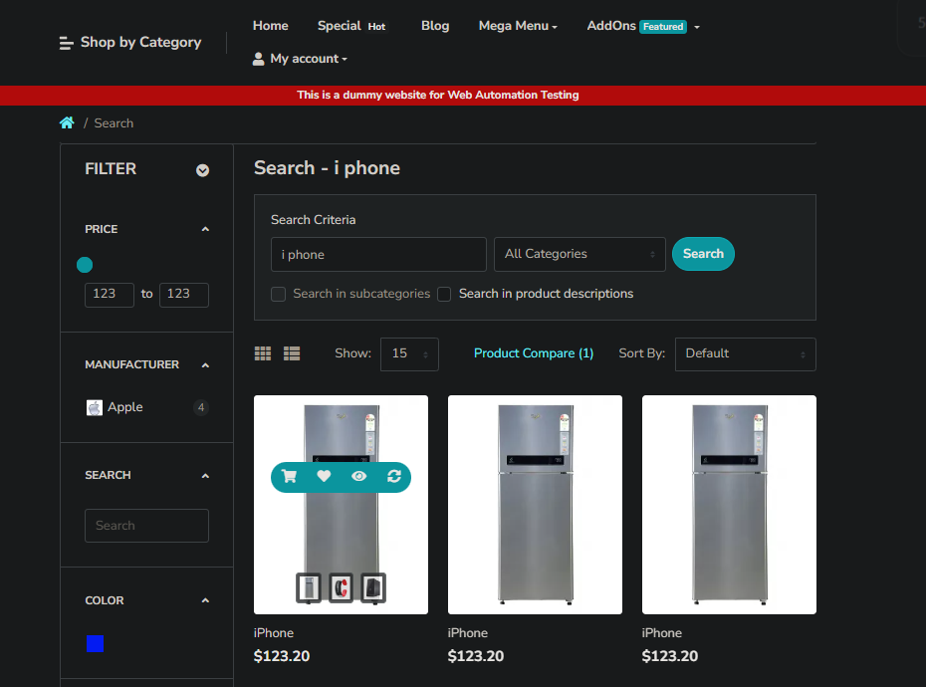

Bug_010

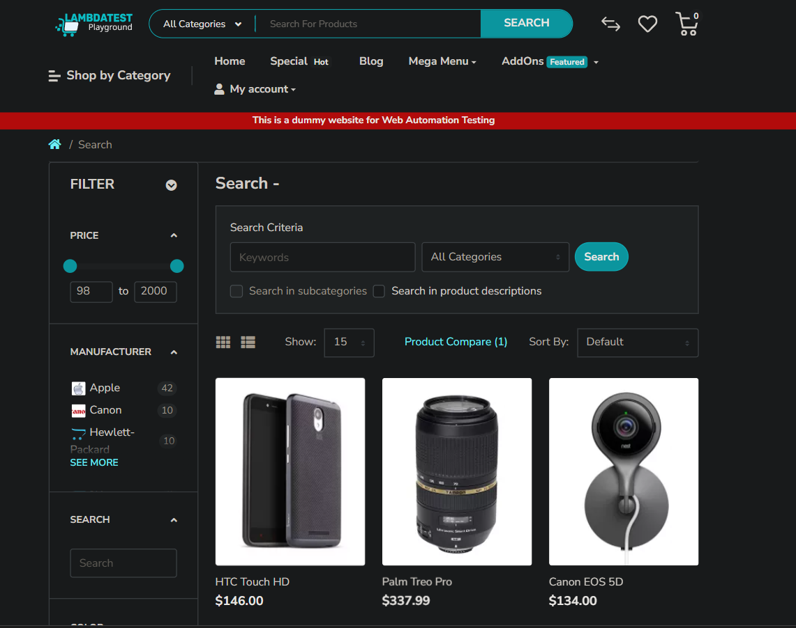

Bug_011

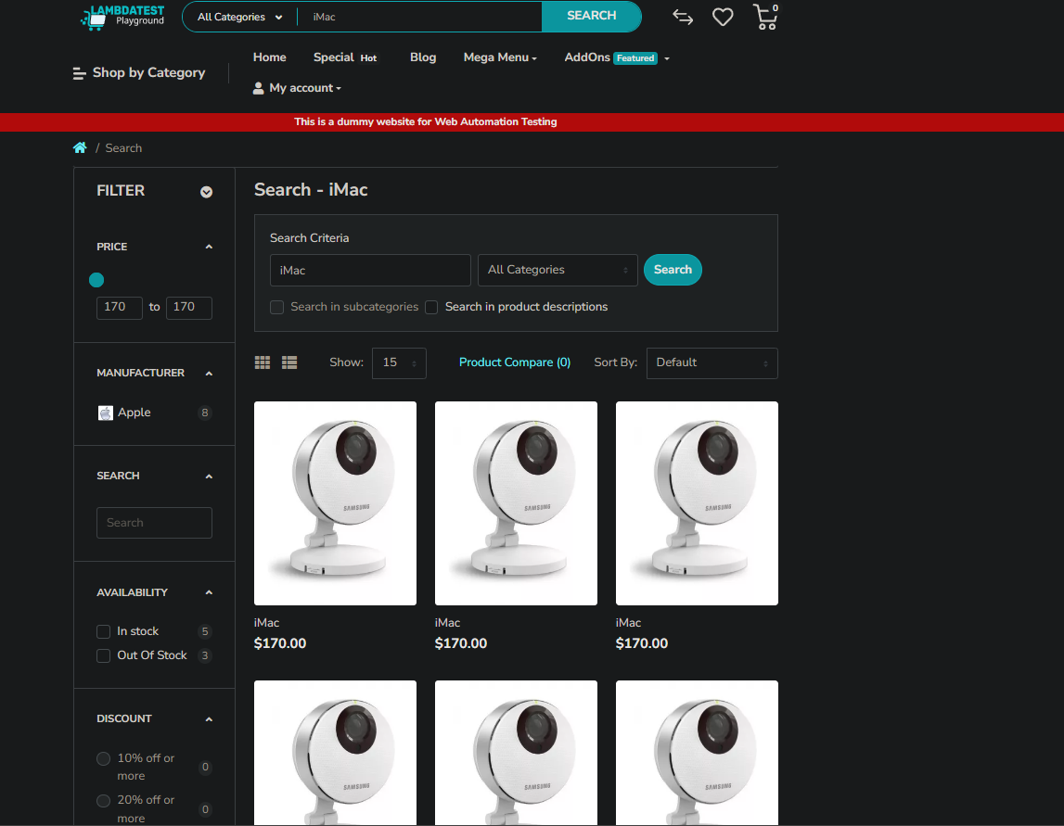

Bug_012

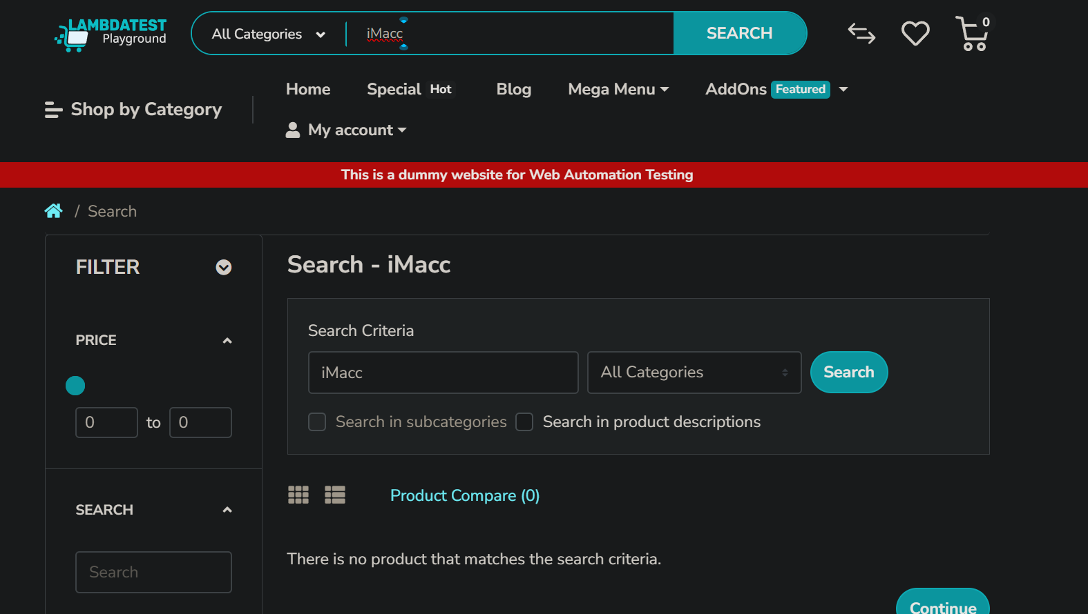

Bug_013

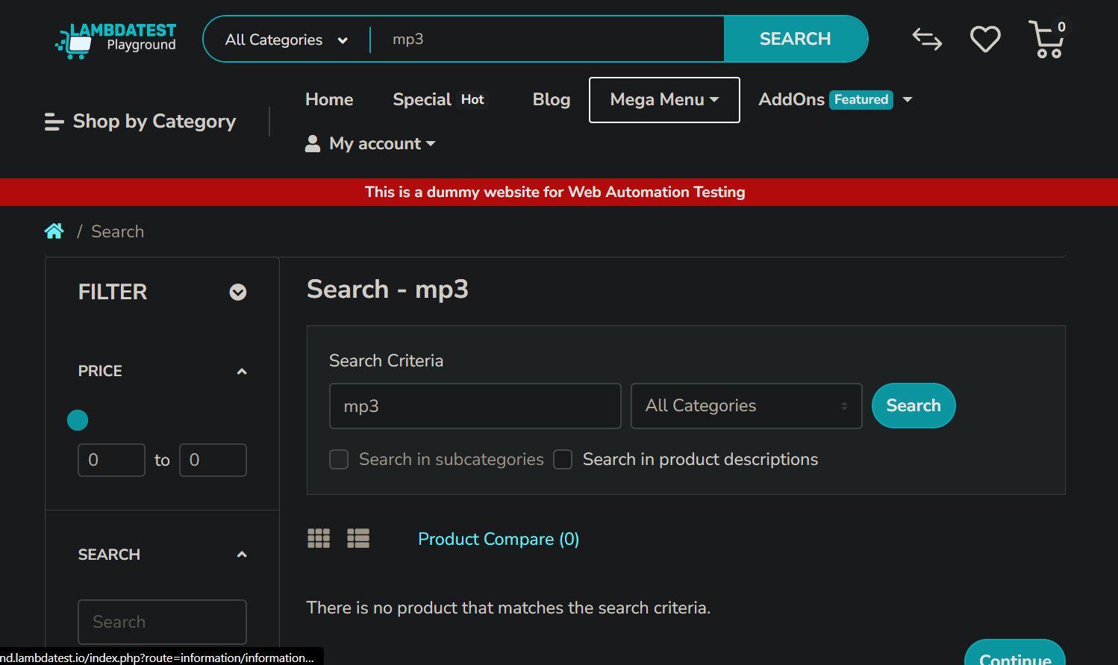

Bug_014

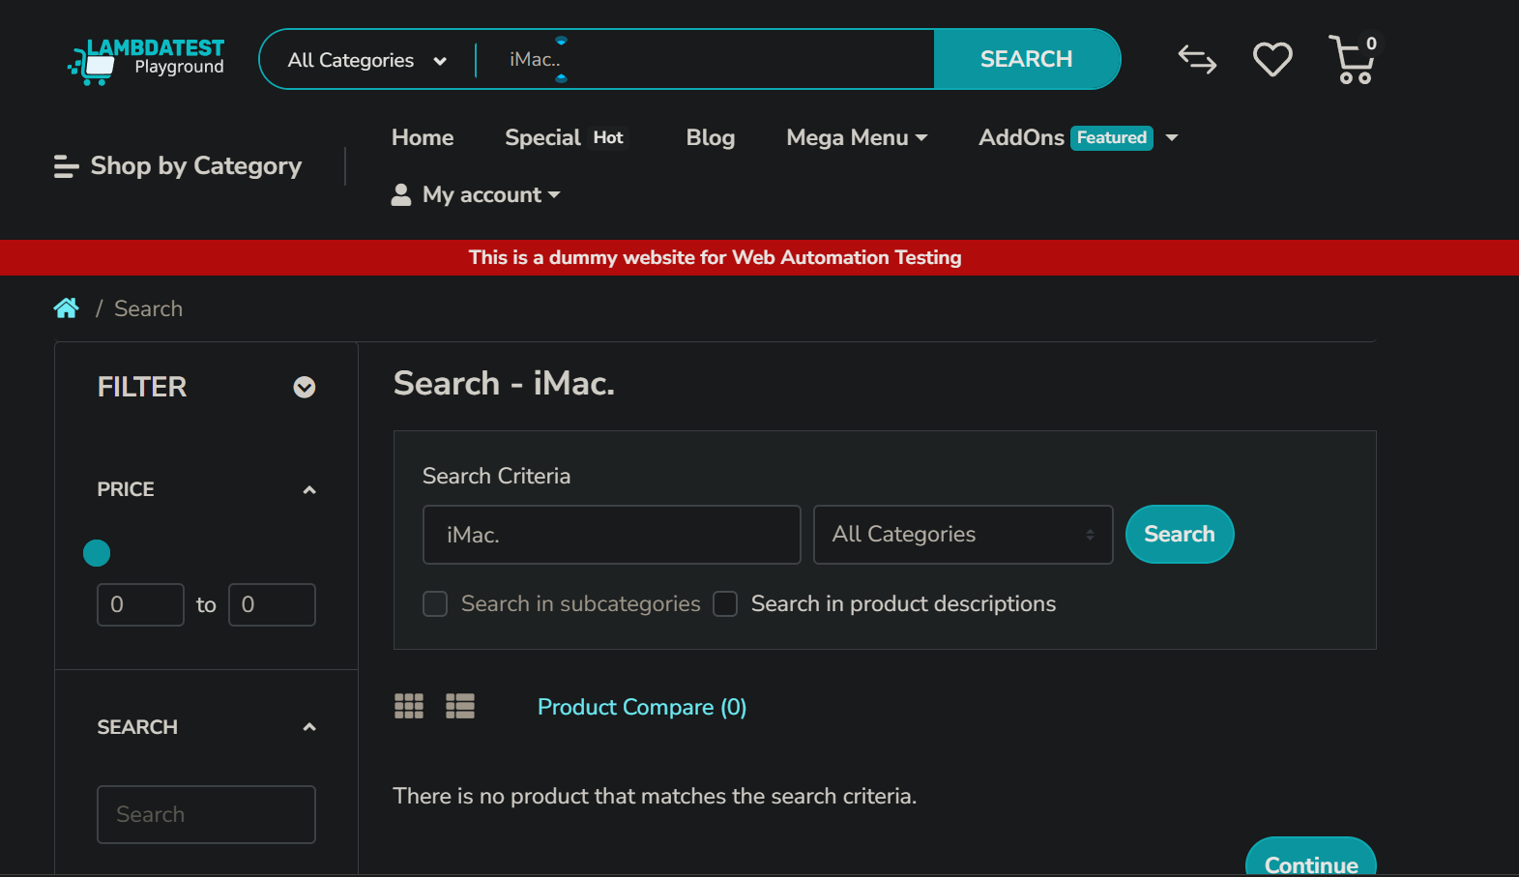

Bug_015

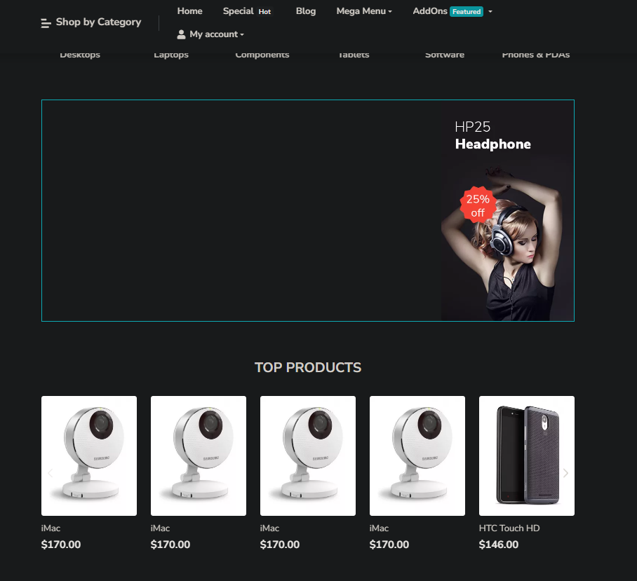

Bug_016

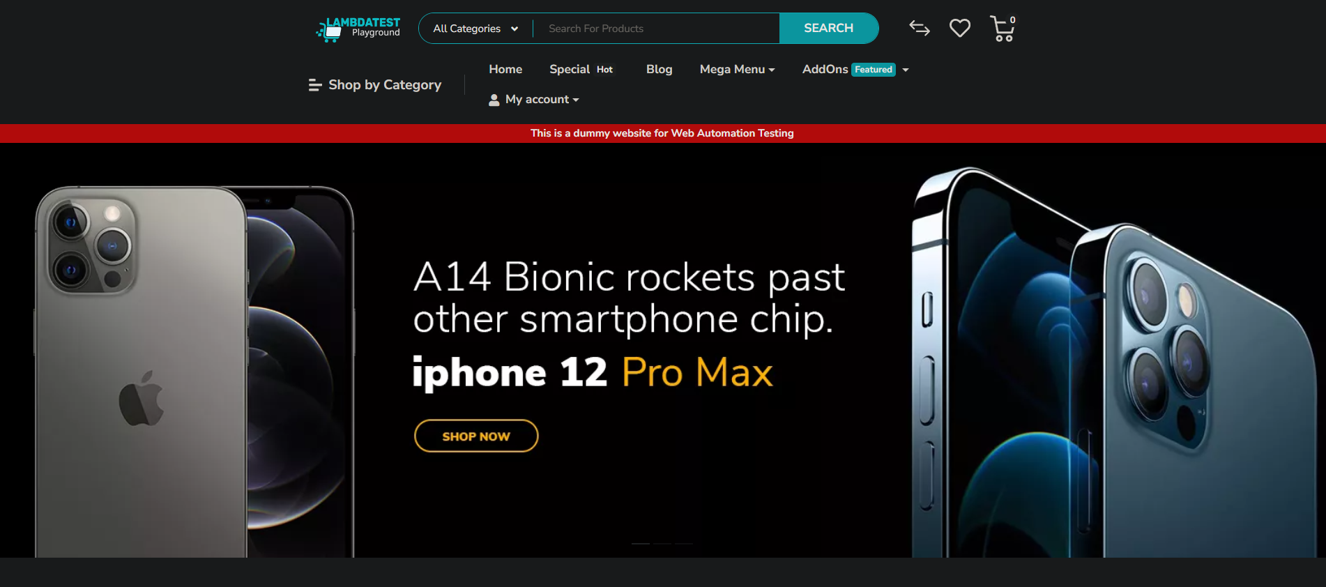

Bug_017

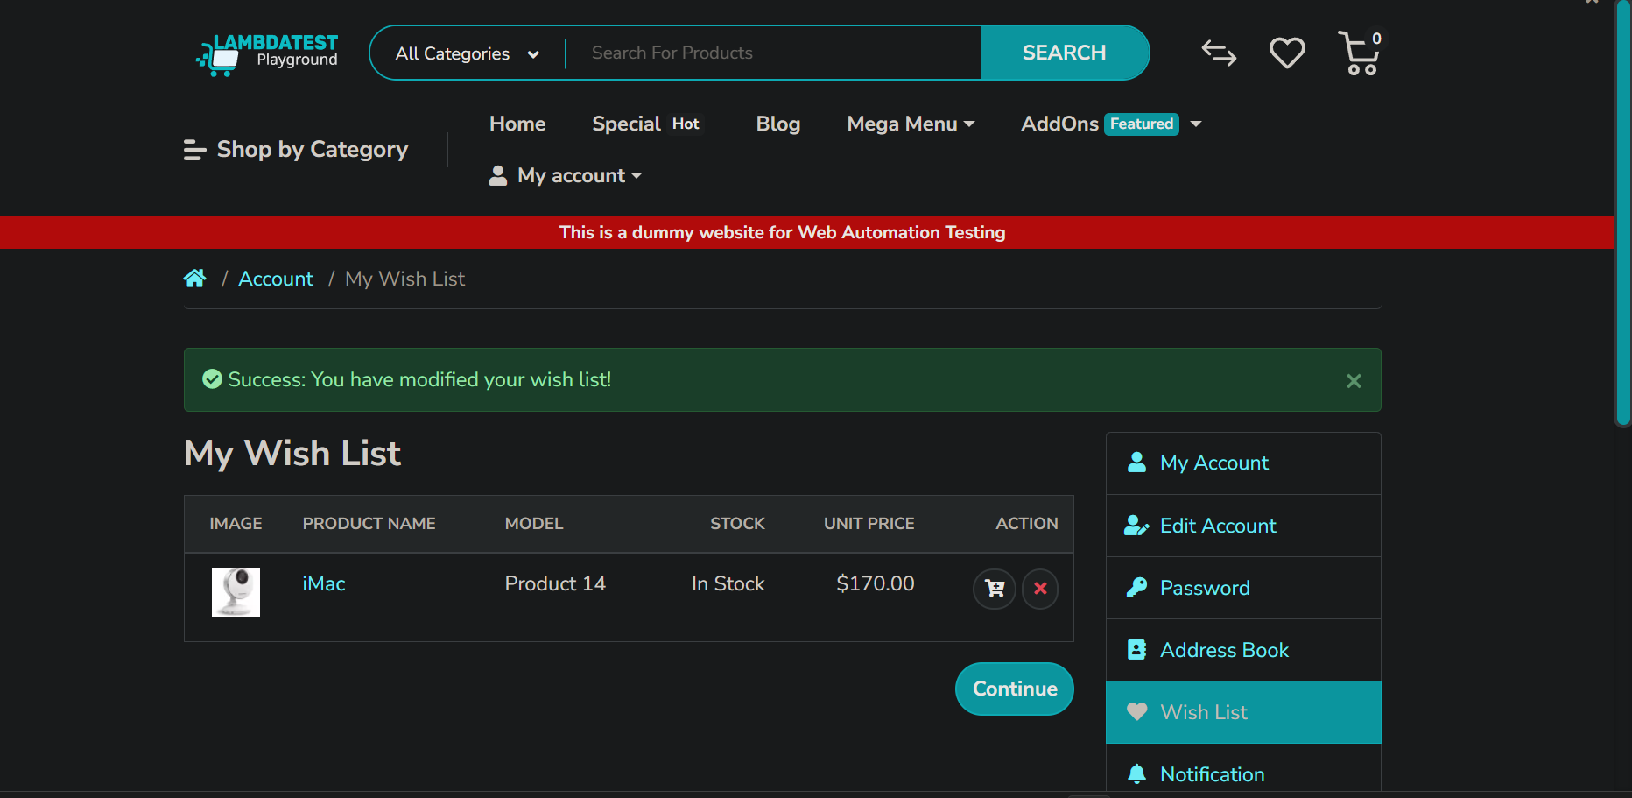

Bug_018

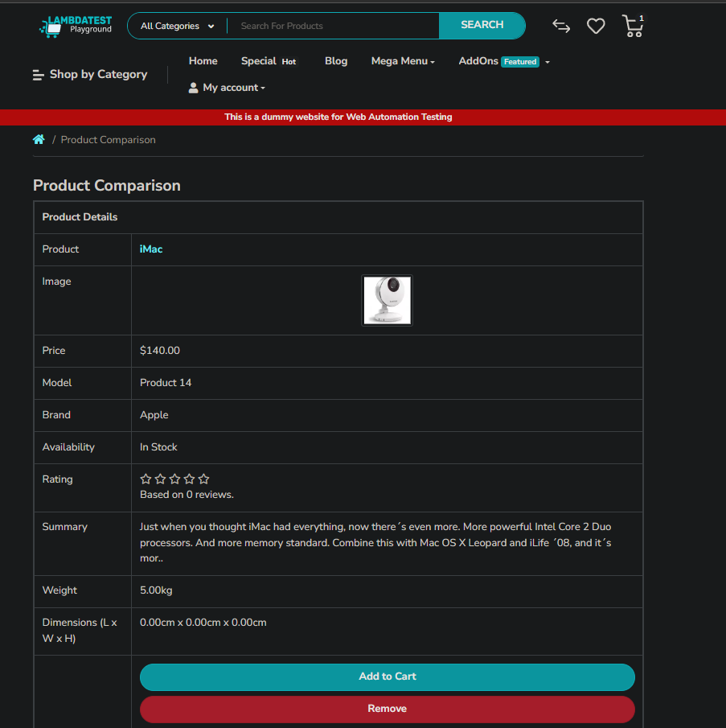

Bug_019

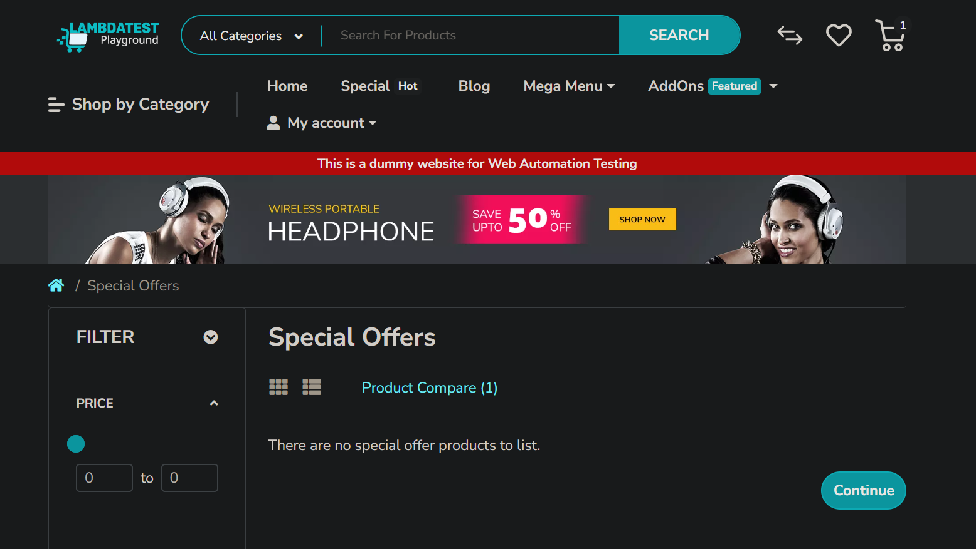

Bug_020

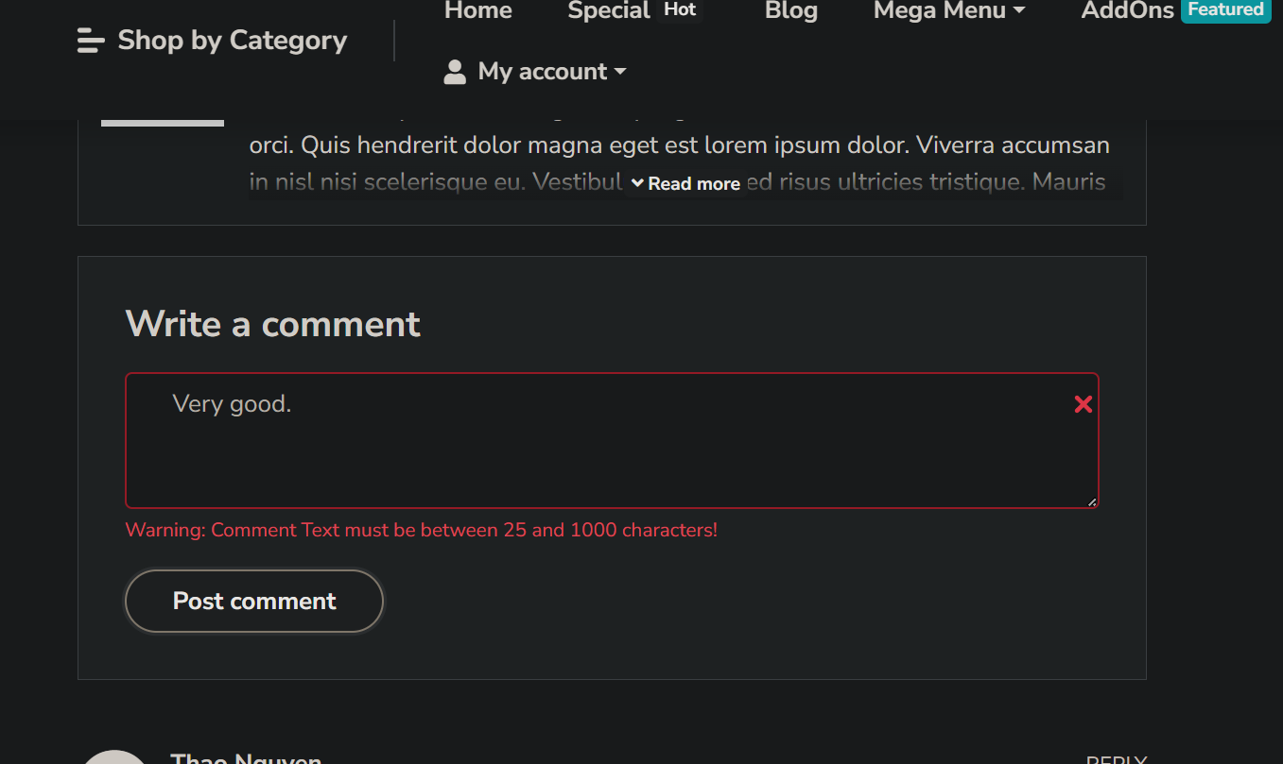

Bug_021

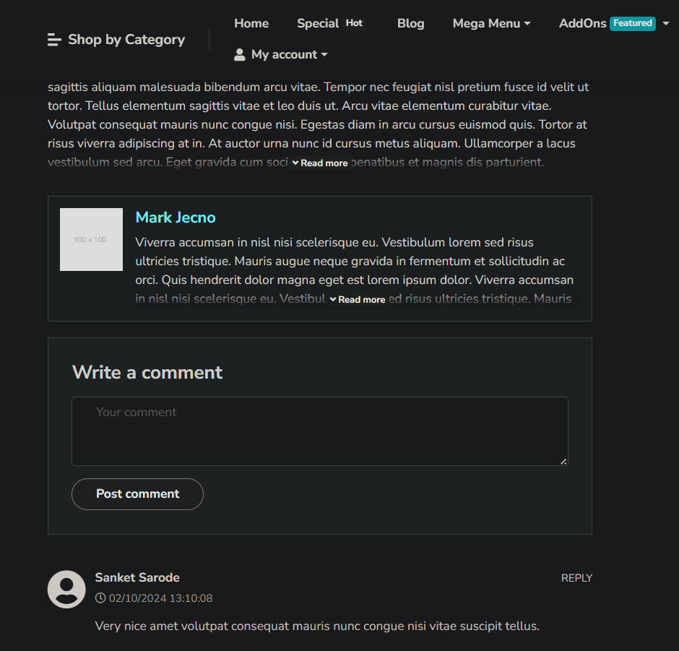

Bug_022

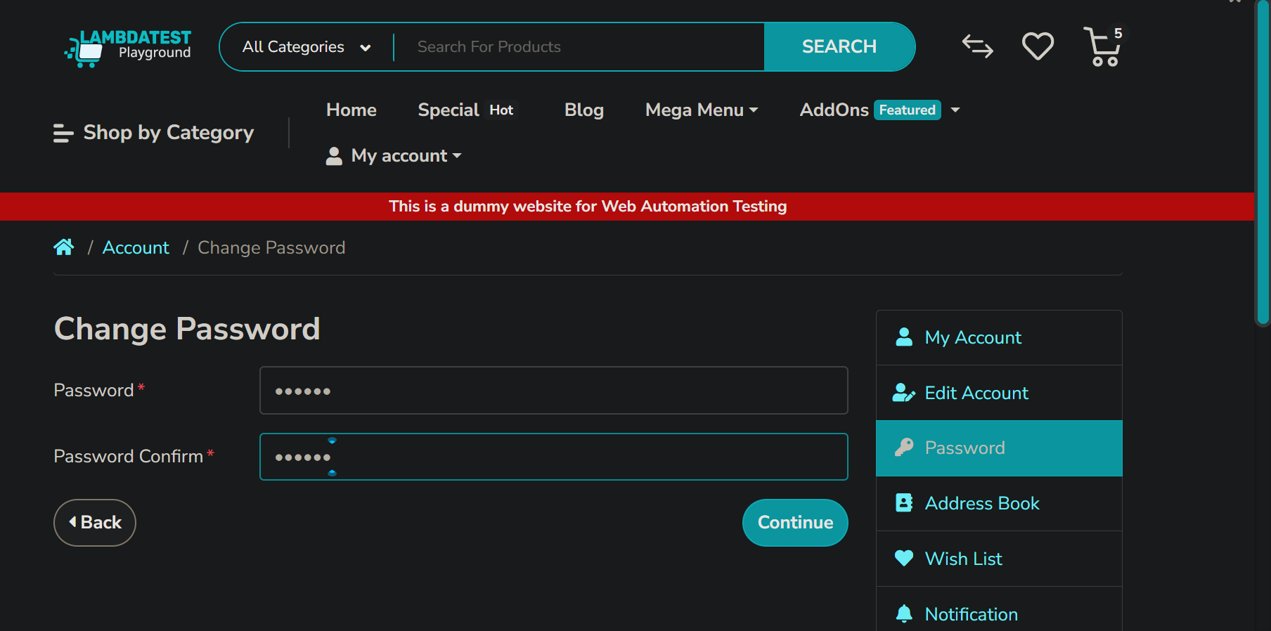

Bug_023

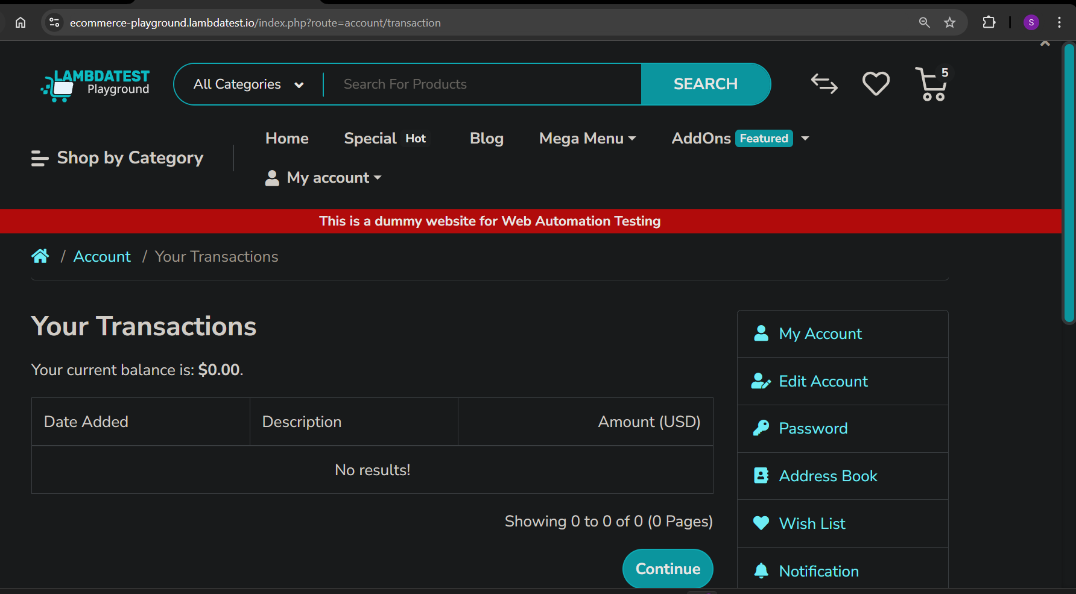

Bug_024

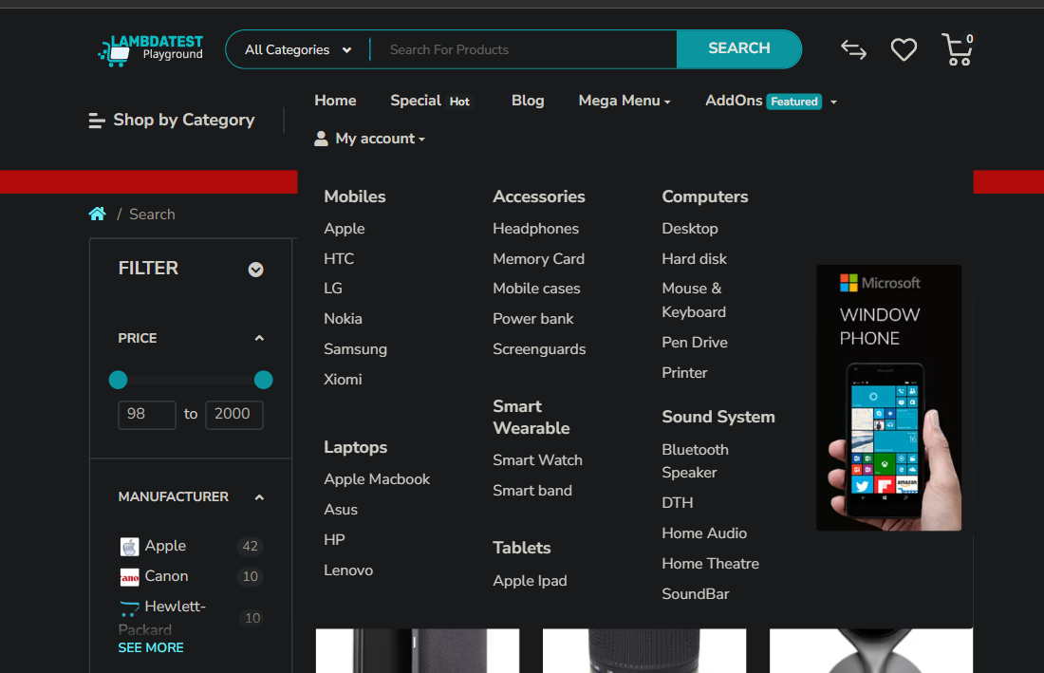

Bug_025



Bug_026

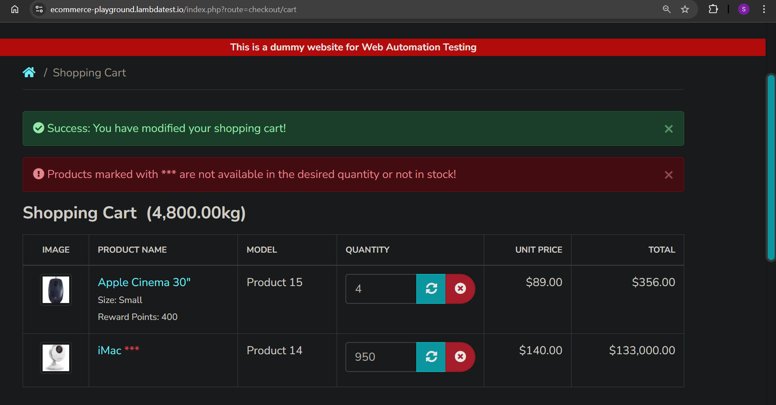Bug_027

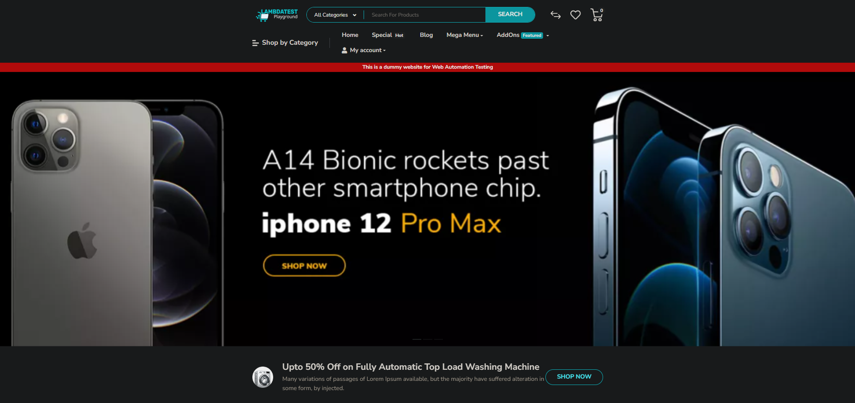

Bug_028



Bug_029

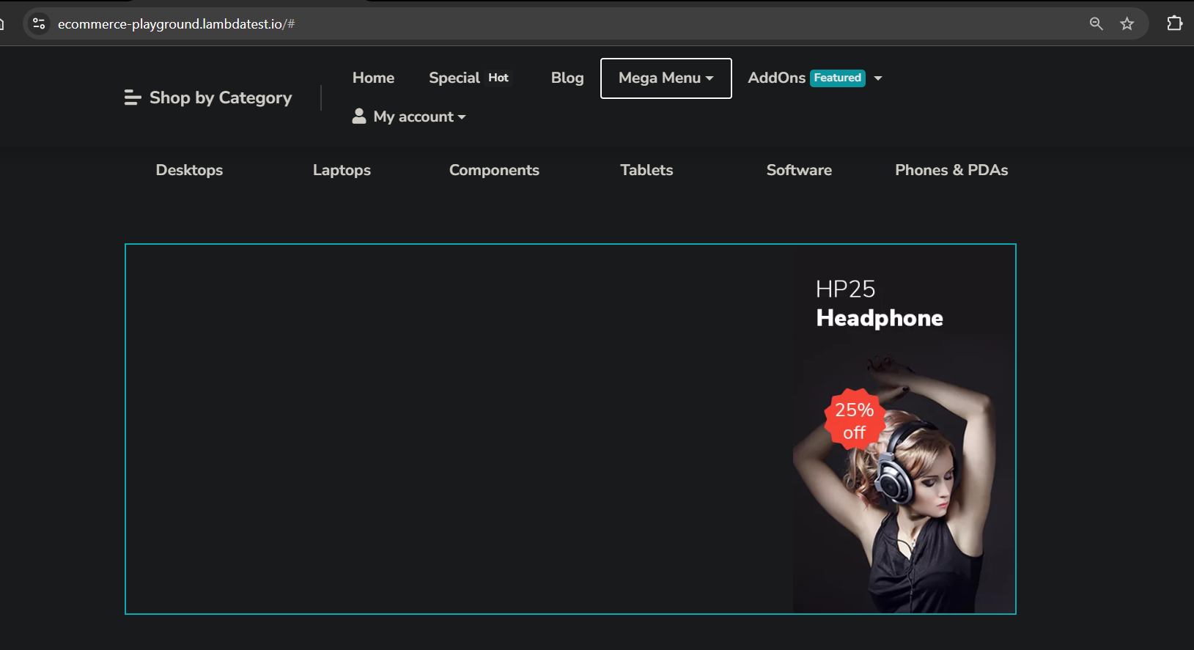

Bug_030



Bug_031

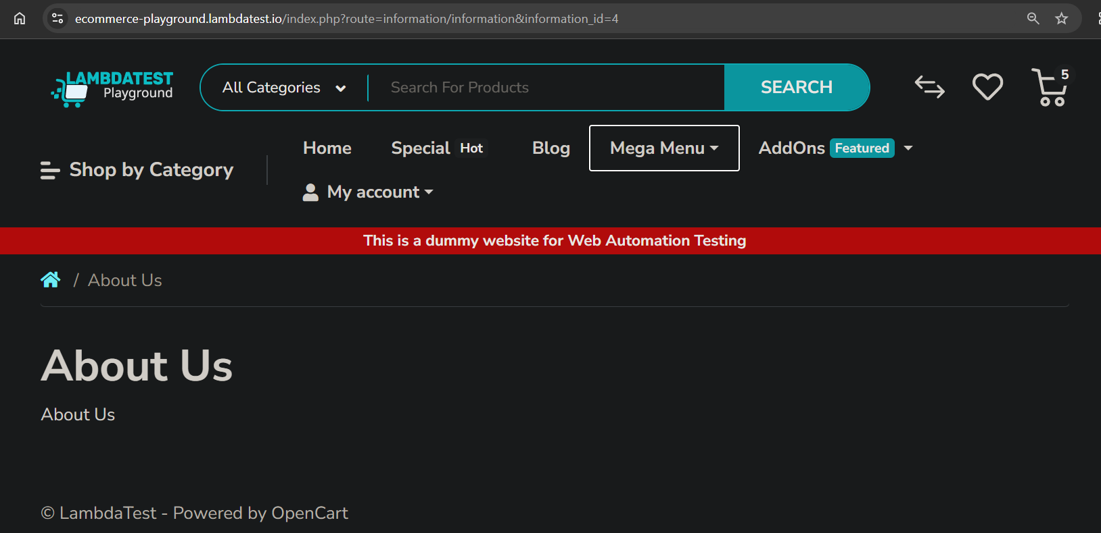

Bug_032

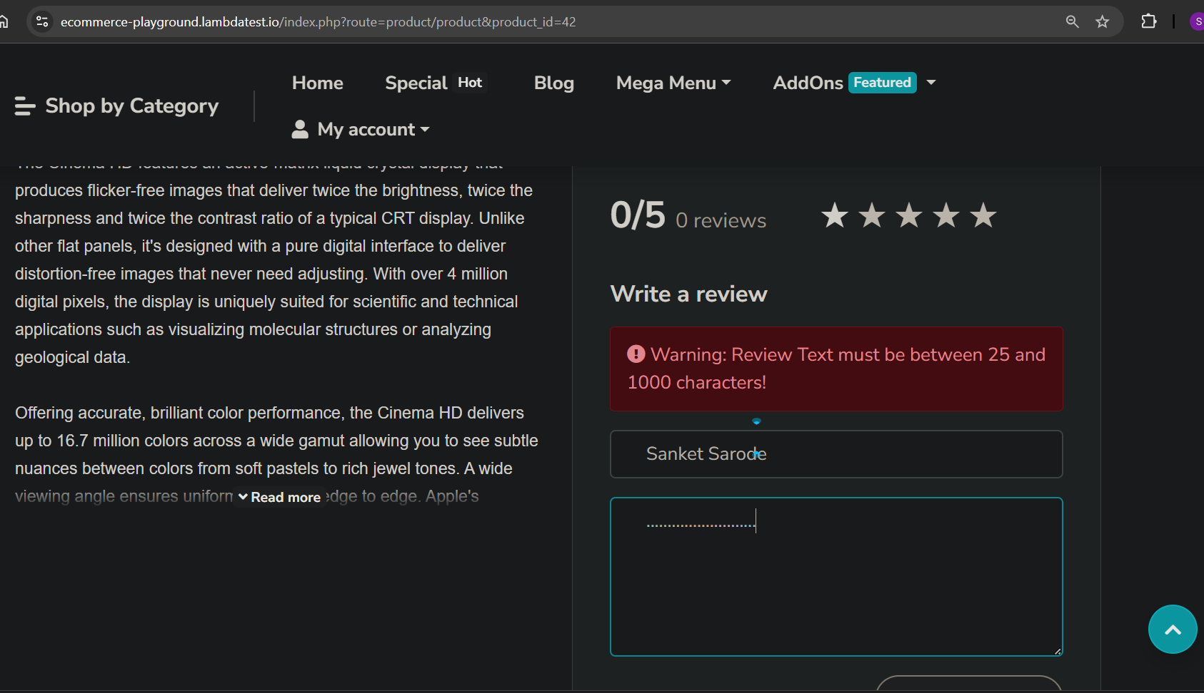

Bug_033

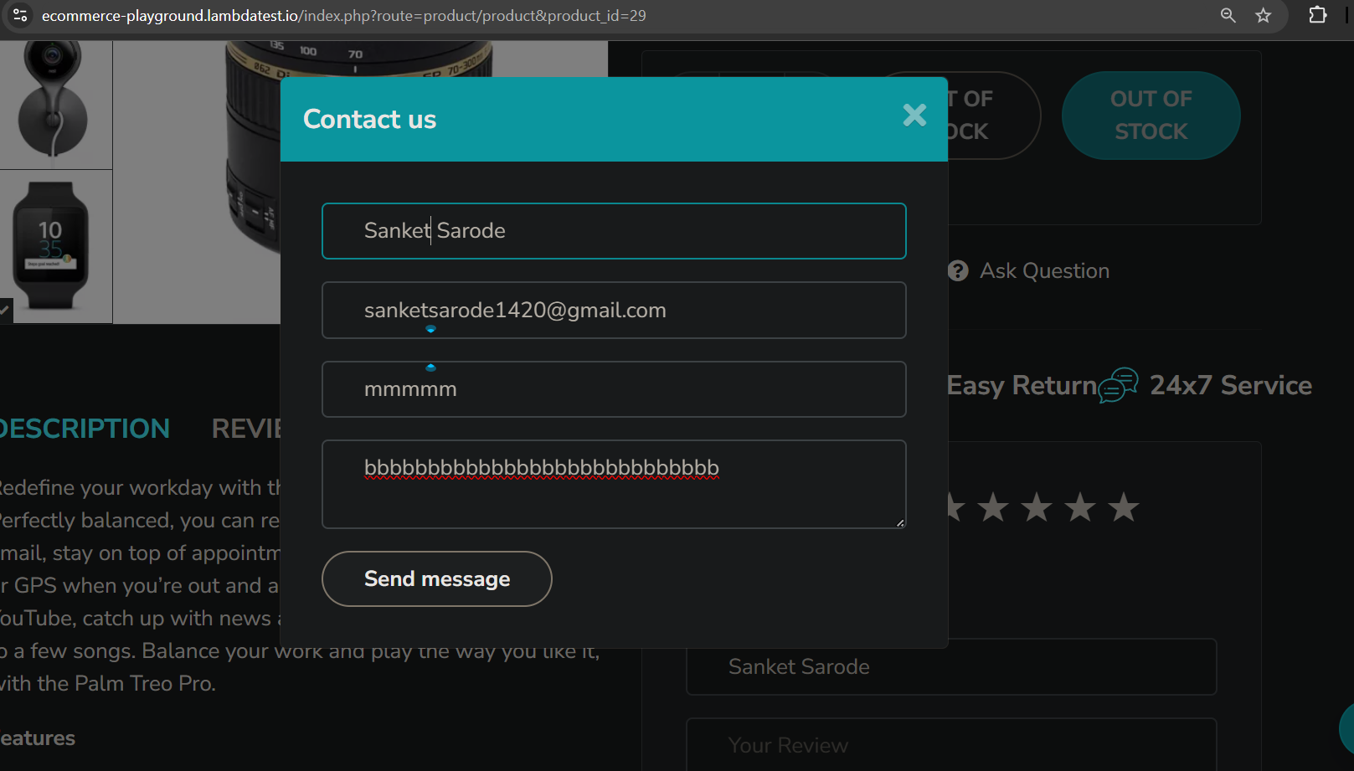

Bug_034

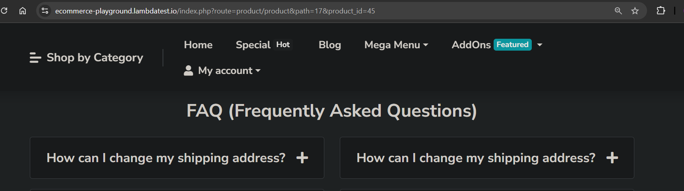

Bug_035

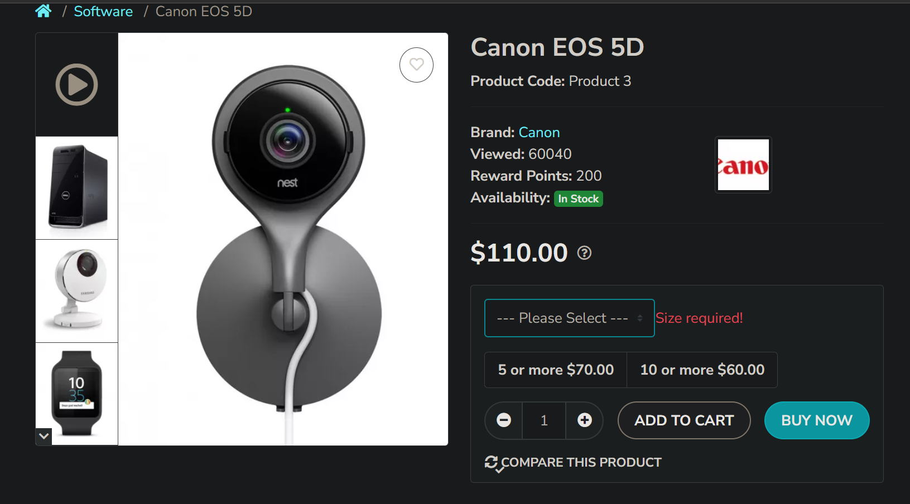

Bug_036

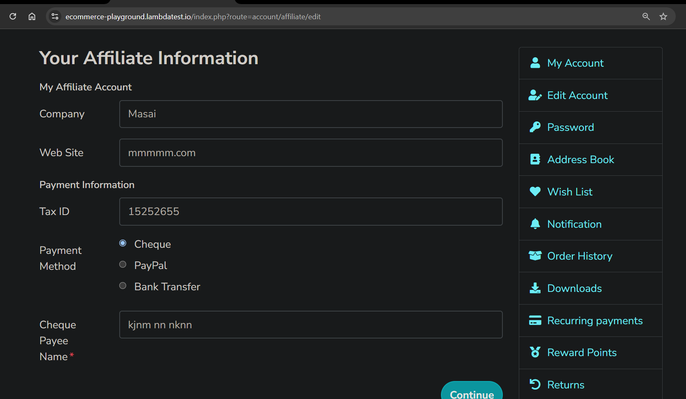

Bug_037

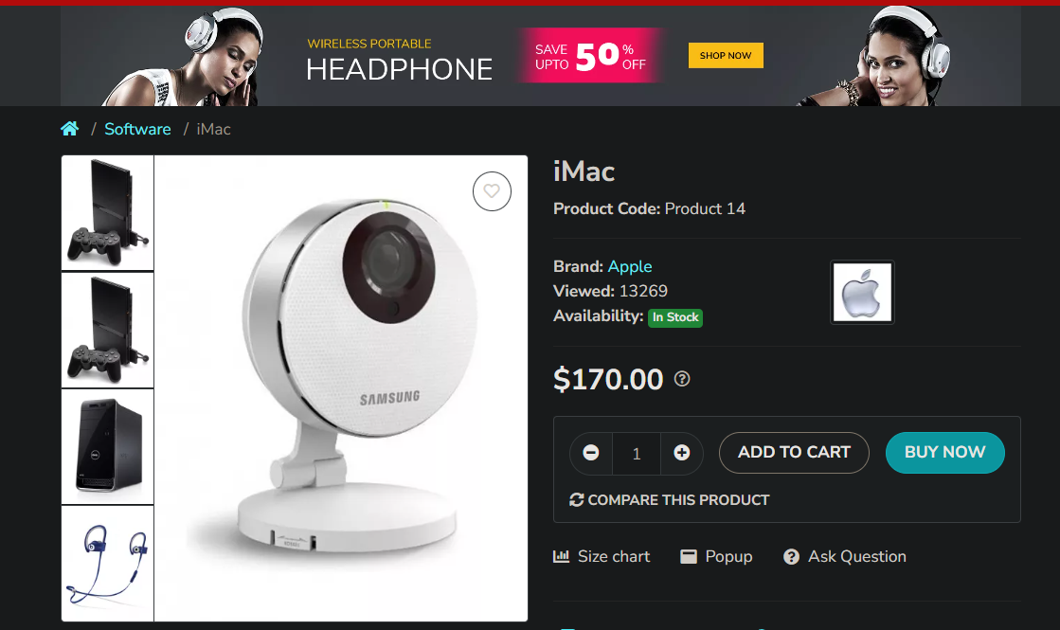

Bug_038



Bug_039

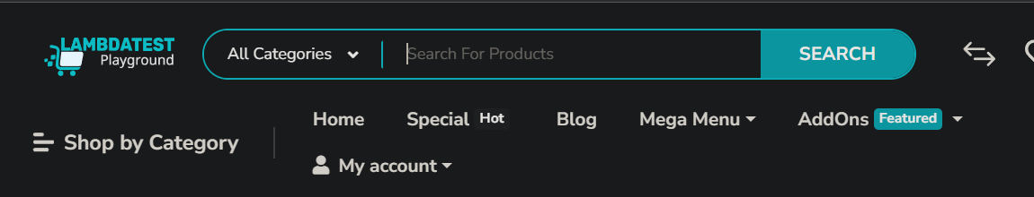Bug_040



Bug_042

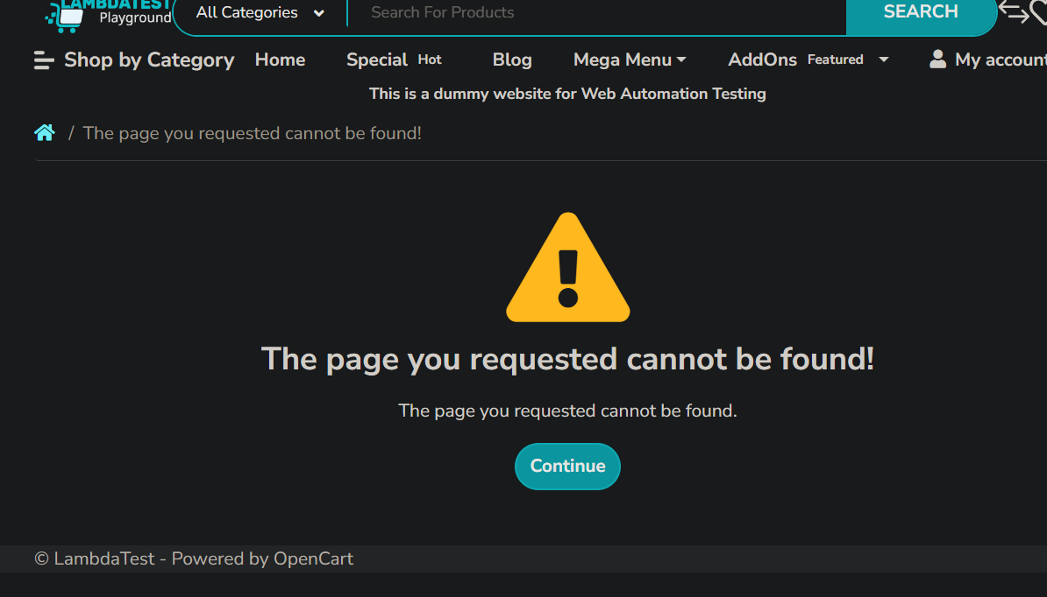Bug_043



Bug_044

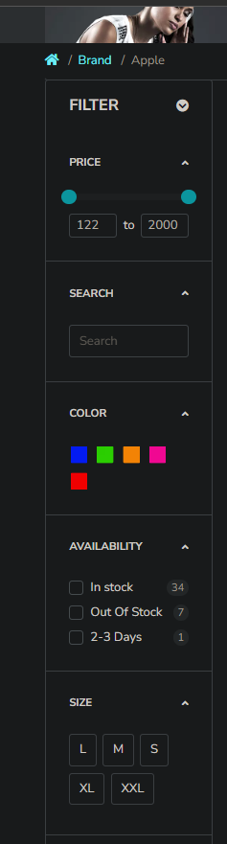

Bug_045

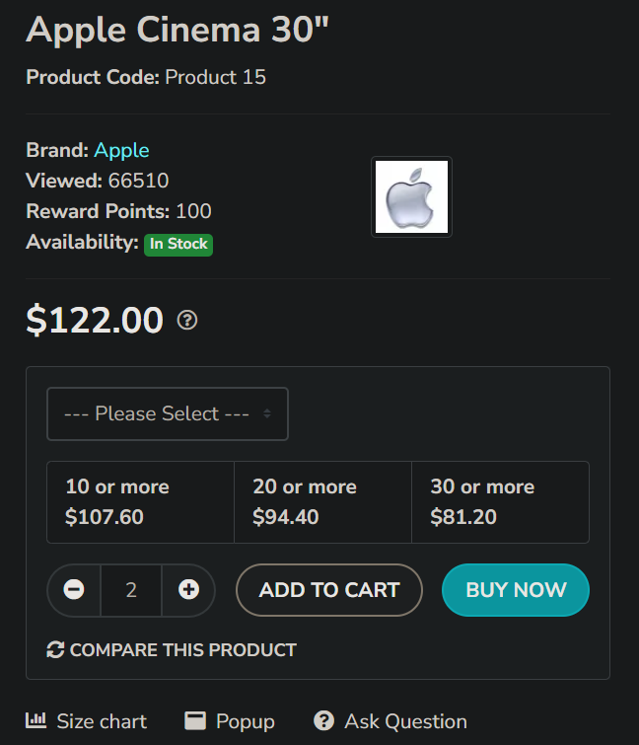

Bug_046



Bug_047

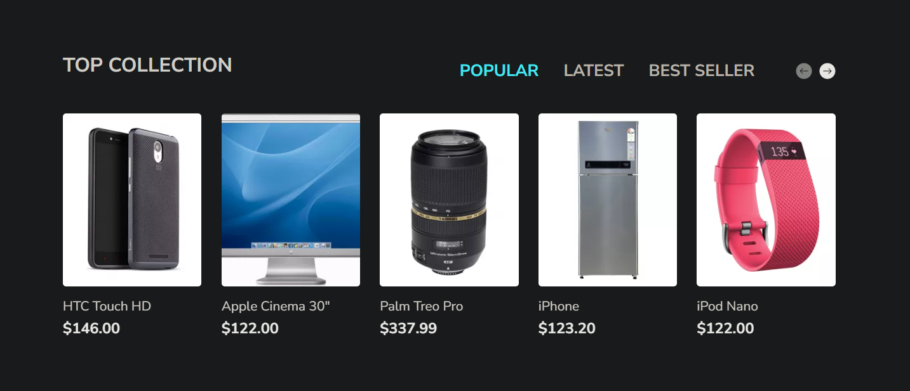

Bug_048

Bug_049



Bug_050

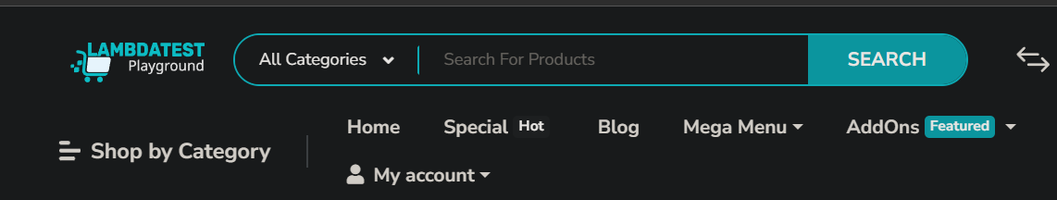Bug_051



Bug_052

Bug_053

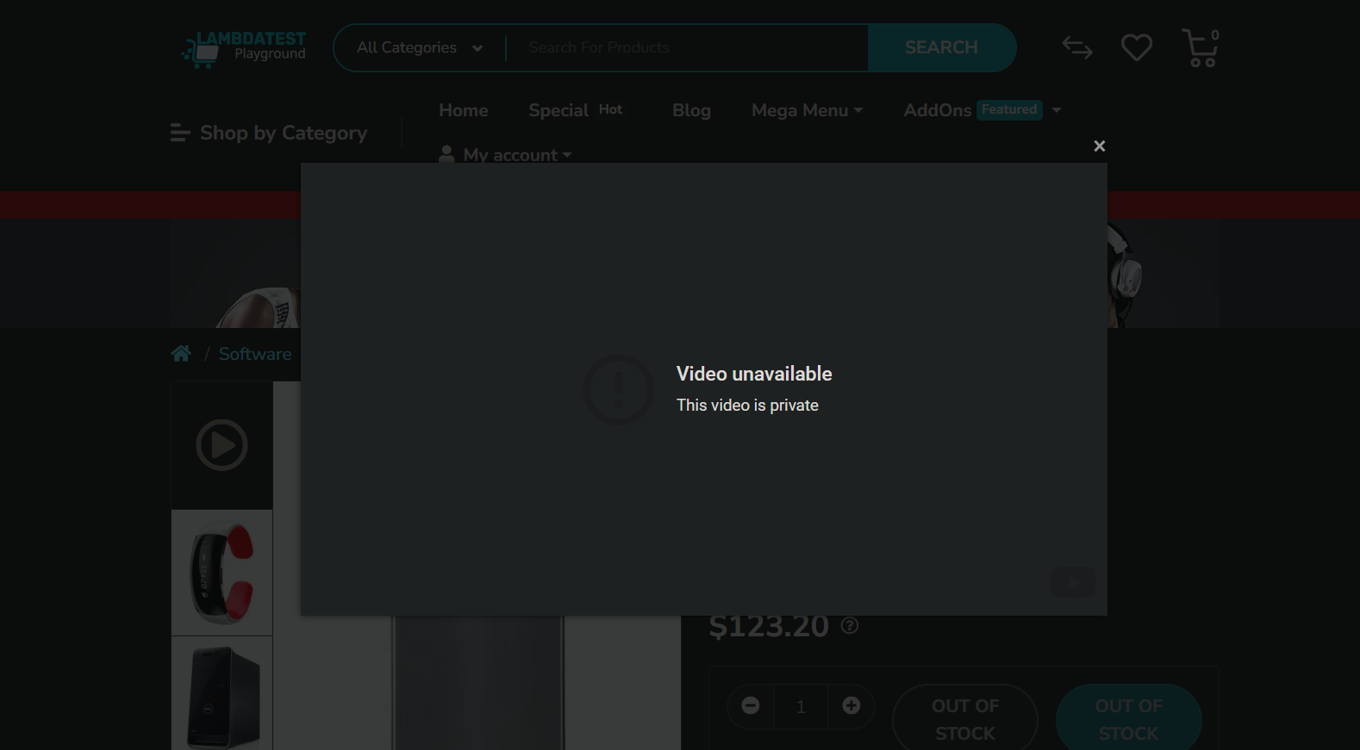

Bug_054



Bug_055



Bug_056



Bug_057



Bug_058



Bug_059

